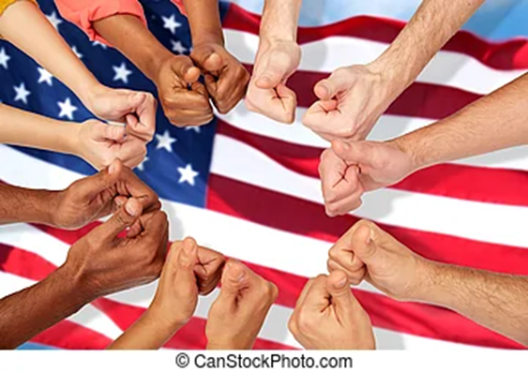
To me immigration, This picture represents all the different cultures and races around the world, and beginning One

This image represents people leaving their families, Friends, and homes to move to another for a better life and better education.

This one is a bit weird because I feel like your passport is like a million dollars. After all, you are free to go wherever and whenever (this presents freedom).

